RUSKIN AND TURNER 1896 |  |  |  | Illuminator unknown
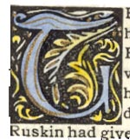 | 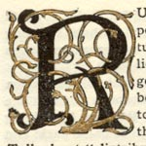 | 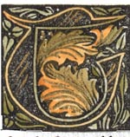 |  |  | 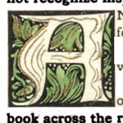 | 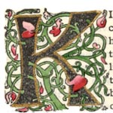
Page 23 | Page 24 | Page 37 |  |  | Page 46 | Page 52
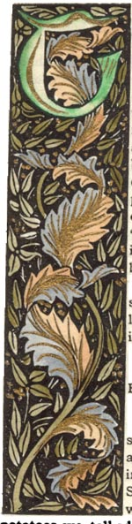 | 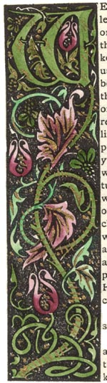 | 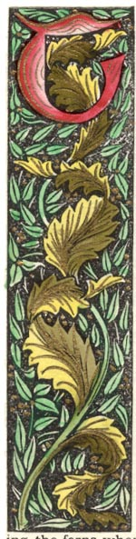 |  |  | 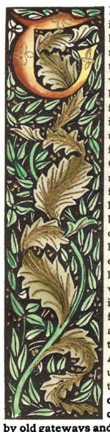 | 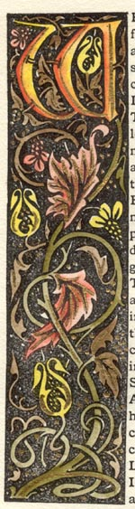 |  |  | 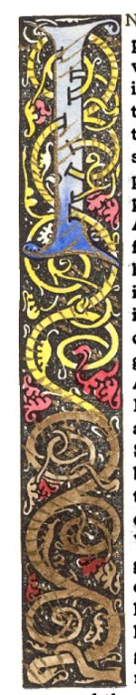
Page 15 | Page 18 | Page 26 |  |  | Page 33 | Page 39 |  |  | Page 41

